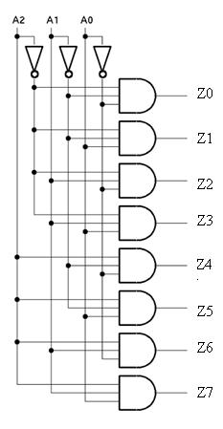**Circuit Diagram & Truth Table:**

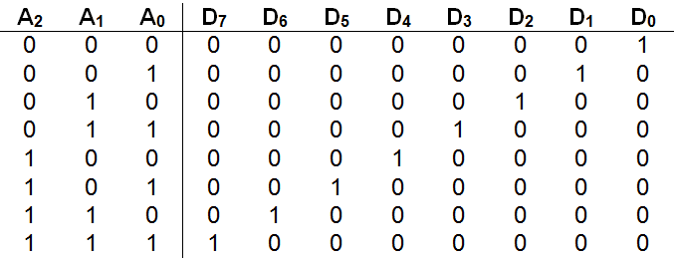

**Code:**

* **Design Module**

module decoder(d0,d1,d2,d3,d4,d5,d6,d7,s0,s1,s2,din);

input s0,s1,s2,din;

output d0,d1,d2,d3,d4,d5,d6,d7;

wire x,y,z;

assign x=~s0;

assign y=~s1;

assign z=~s2;

assign d0=(x&y&z);

assign d1=(s1&x&z);

assign d2=(s0&y&z);

assign d3=(s0&s1&z);

assign d4=(s2&x&y);

assign d5=(s2&y&s0);

assign d6=(s2&s1&x);

assign d7=(s2&s1&s0);

endmodule

* **TestBench**

module Baig;

reg s0,s1,s2;

wire d0,d1,d2,d3,d4,d5,d6,d7;

decoder dc(d0,d1,d2,d3,d4,d5,d6,d7,s0,s1,s2);

initial

begin

s0=1'b0; s1=1'b0; s2=1'b0; #20

s0=1'b1; s1=1'b0; s2=1'b0; #20

s0=1'b0; s1=1'b1; s2=1'b0; #20

s0=1'b1; s1=1'b1; s2=1'b0; #20

s0=1'b0; s1=1'b0; s2=1'b1; #20

s0=1'b1; s1=1'b0; s2=1'b1; #20

s0=1'b0; s1=1'b1; s2=1'b1; #20

s0=1'b1; s1=1'b1; s2=1'b1; #20

$finish;

end

endmodule

**Output:**

